Project Development Phase
Model Performance Test
Date | 28 September 2026
Team ID | 6ab221d587602313e82c60c9
Project Name | Import Data using Transform Maps (Spreadsheet)
Maximum Marks | [Maximum Marks]
Model Performance Testing:
Project team shall fill the following information in model performance testing template.
S.No. | Parameter | Values | Screenshot
1. | Model Summary | ServiceNow data import setup for data management using Data Source, Import Set and Transform Map.  Note : Import Records: if the spreadsheet data matches correctly with the mapped fields, then records will be created or updated in the target table; else the row is skipped and an error is shown in Transform History. | 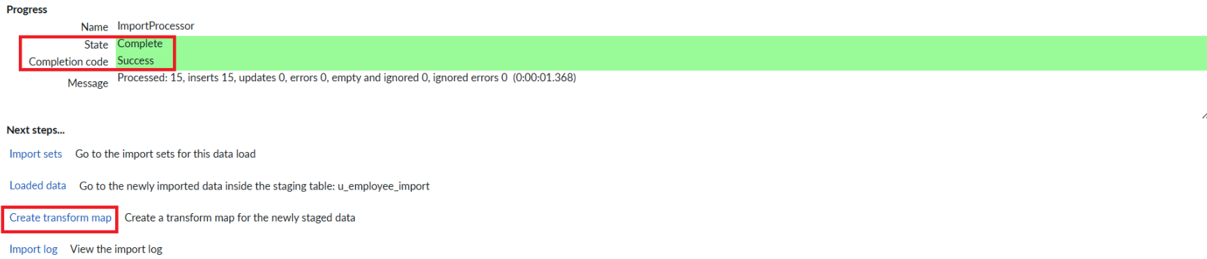  
2. | Accuracy | Import Accuracy = (Records inserted + updated) / Total rows in spreadsheet x 100  Valid Data Accuracy - [XX]%  Overall Import Accuracy - [XX]% |   
3. | Confidence Score (Only Yolo Projects) | Not applicable: this is a data import project, not a YOLO / object detection project. | N/A (no screenshot required)

